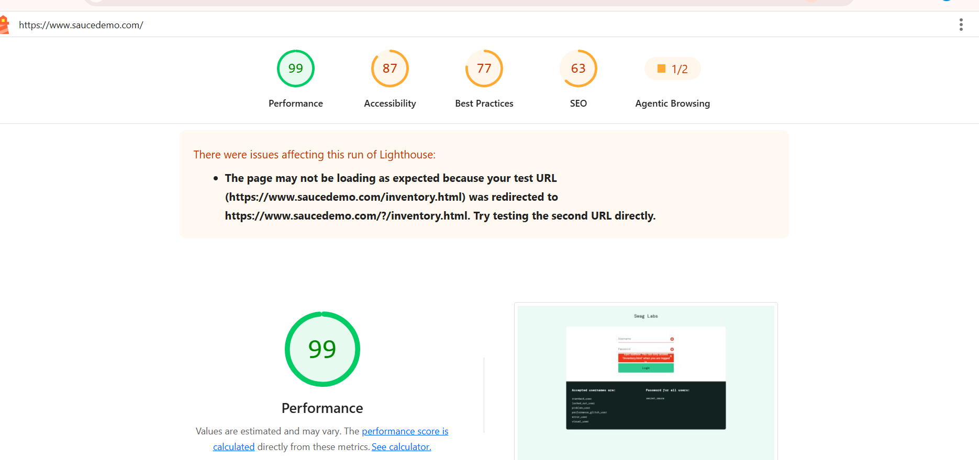
- Keyboard Accessibility
- All major can reach using tab key.

- Form Accessible (login page)
- Error message are not fully accessible to screen readers.

- Visual accessibility
- Text size is generally readable.

- Screen reader consideration
- Most button have understandable name.

- Usability Barrier
- Lack of short cut navigation increase efforts for user with disability.

